*Enterprise feature Analytics*

[Js Library to use on the feature](https://developers.google.com/chart/interactive/docs/gallery)   
<https://developers.google.com/chart/interactive/docs/gallery>  
  
List of Chart that we should implement:

[Pie Chart](https://developers.google.com/chart/interactive/docs/gallery/piechart)

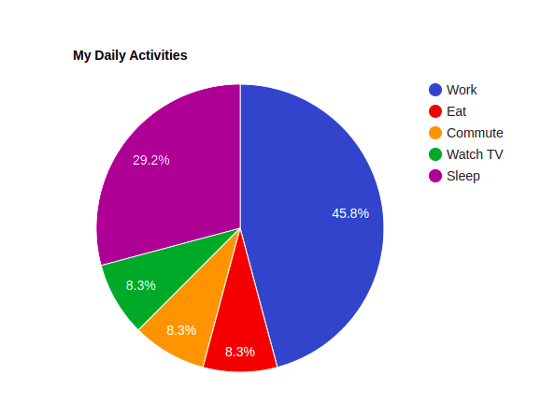

**Details:**

* **we had totally 3 colors divided by 3 context (status )**
  + **not start learning**
  + **In progress**
  + **Finished**
* **the numbers is the numbers of learners per status (%)**

[**Line Chart**](https://developers.google.com/chart/interactive/docs/gallery/linechart)

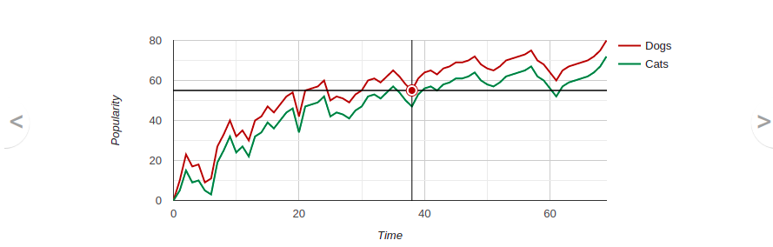

**Details :**

* **the graph has 2 dimensions:**
  + **X: Month**
  + **Y: total number of learner who subscribe a min 1 course**
* **Have 3 Shapes:**
  + **Active learner**
  + **not started Yet**
  + **Finished Learner**

[**Column Chart**](https://developers.google.com/chart/interactive/docs/gallery/columnchart)

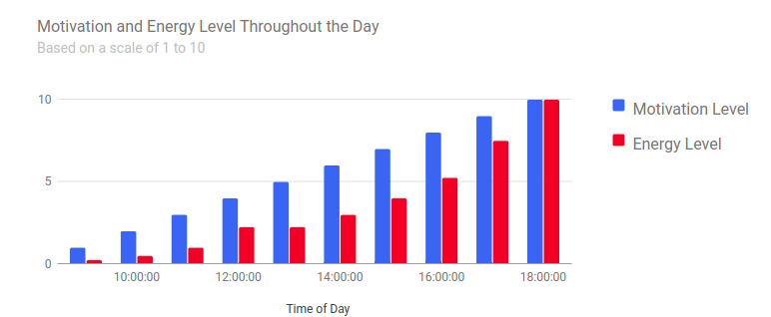

**Details:**

* **the graph has 2 dimensions:**
  + **X: Total number of learner who subscribe a courses**
  + **Y: courses name**
* **Each course have 3 bar**
  + **Learner who subscribe a course but not started yet**
  + **In progress**
  + **finished**

[Pie Chart](https://developers.google.com/chart/interactive/docs/gallery/piechart)



**Les partitions des apprenants selon les fuseaux horaires  
  
We have totally 4 colors:**

* **8h - 10h**
* **10h - 12h**
* **14 - 16h**
* **others**